Ask: Act as a senior architect and understand the entire project code. This will be useful for futher enhancement or changes in the project
Plan: Project is having implementation for Selenium with java. When i select Language as Java and Selenium as Browser Engine in the Setting tab. Selenium with Java code is getting generated successfully. I want to implement for TypeScript as Selected Language and Playwright as Browser engine without impactiong the existing implementation for Selenium Java. Analyze the impacted files and fuctions. I need to review and approve. Then proceed with implementation in Agen mode
Agent: Proceed with the implementation
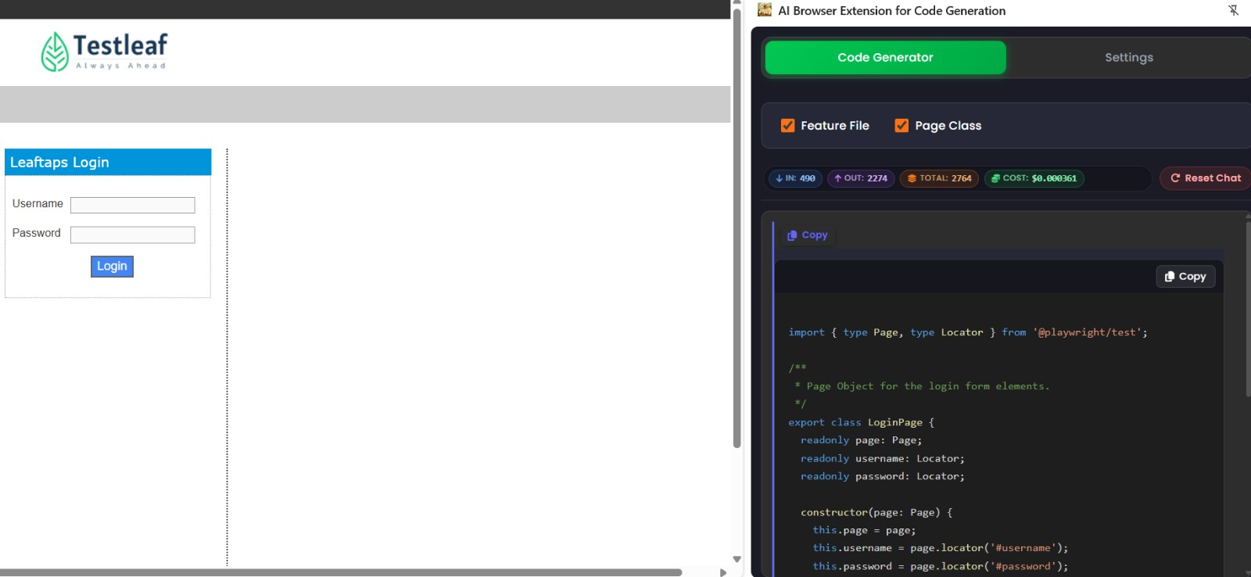

Ask: There are 3 models available under Select Model dropdown in the Settings tab. I want to add one more model. Analyze the code and provide me the class and function where i need to update the code
